AISSCE 2019-20
CLASS-XII
COMPUTER SCIENCE (NEW) (083)
PROJECT-<“HOTEL MANAGEMENT SYSTEM”>

KENDRIYA VIDYALAYA ALIGANJ LUCKNOW

SUBMITTED BY:
Roll No:
Name: Akash kumar
Class: XII -A
Date:

- Signature of Internal Examiner:

- Signature of External Examiner:
CONTENTS
- Acknowledgement
- Certificate
- Introduction
- About Project
- Source code
- Sample run
- Suggestions for Improvement
- Bibliography

ACKNOWLEDGEMENT

I wish to express my deep gratitude and sincere thanks to the Principal, Smt. Sangeeta Yadav for her encouragement and for all the facilities that she provided for this project work.
I extend my hearty thanks to sir Mr. Amit Kumar Panday, our Computer Teacher, who guided me to the successful completion of this project. I take this opportunity to express my deep sense of gratitude for his invaluable guidance, constant encouragement, immense motivation, which has sustained my efforts at all stages of this Project work.
I can’t forget to offer my sincere thanks to my parents and also to my classmates who helped me to carry out this project work successful and for their valuable advice and support, which I received from them time to time.

AKASH KUMAR
Class: - XII – A
KENDRIYA VIDYALAYA
ALIGANJ LUCKNOW
CERTIFICATE
This is to certify that Project entitled
“HOTEL MANAGEMENT SYSTEM”
is original and genuinely developed by AKASH KUMAR
for the fulfillment of requirement of AISSCE – 2019 Practical Exam in the subject Computer Science(New)-083.

Internal Examiner:

External Examiner:

INTRODUCTION
Connecting Python application with MySQL

- Every application required data to be stored for future reference to manipulate data. Today every application stores data in database for this purpose.
- Python allows us to connect all types of database like Oracle, SQL Server, MySQL.
- Before we connect python program with any database like MySQL we need to build a bridge to connect Python and MySQL.

To build this bridge so that data can travel both ways we need a connector called “mysql.connector”.
We can install “mysql.connector” by using following methods:
At command prompt (Administrator login)
Type “pip install mysql.connector” and press enter
(internet connection in required)
This connector will work only for MySQL 5.7.3 or later
Or open “https://dev.mysql.com/downloads/connector/python/”
and download connector as per OS and Python version
- Once the connector is installed you are ready to connect your python program to MySQL.
The following steps to follow while connecting your python program with MySQL
- Open python
- Import the package required (import mysql.connector)
- Open the connection to database
- Create a cursor instance
- Execute the query and store it in result-set
- Extract data from result-set
- Clean up the environment

- Importing mysql.connector
import mysql.connector
Or
import mysql.connector as ms
Here “ms” is an alias, so every time we can use “ms” in place of “mysql.connector”
- Open a connection to MySQL Database
- To create connection, connect() function is used
- Its syntax is:
  - ¤ connect(host=<server_name>,user=<user_name>,
  - passwd=<password>[,database=<database>])
- Here server_name means database servername, generally it is given as “localhost”
- User_name means user by which we connect with mysql generally it is given as “root”
- Password is the password of user “root”
- Database is the name of database whose data(table) we want to use
- Creating Cursor
It is a useful control structure of database connectivity.
When we fire a query to database, it is executed and result-set (set of records) is sent over he connection in one go.
We may want to access data one row at a time, but query processing cannot happens as one row at a time, so cursor help us in performing this task. Cursor stores all the data as a temporary container of returned data and we can fetch data one row at a time from Cursor.
- Creating Cursor and Executing Query
TO CREATE CURSOR
Cursor_name = connectionObject.cursor()
For e.g.
mycursor = mycon.cursor()
TO EXECUTE QUERY
We use execute() function to send query to connection
Cursor_name.execute(query)
For e.g.
mycursor.execute(‘select * from emp’)

ABOUT PROJECT

This program of “Hotel management System” mainly deals with the basic easy-to-use concept of managing and booking records for hotels.
Under this program we can visualize the implementation of the records in the Hotel reservations that how we enter names and make selections like which type of suits one needs and under what cost it is easily available.

This program can mainly help a hotel management staff for accessing the entries of customer’s, allocation of rooms, check inn dates, check out dates, etc.
This program is graphically visualized so one can work on the program graphically which makes the program more interactive and elegant.

SOURCE CODE
CODES FOR CREATING DATABASE AND TABLES
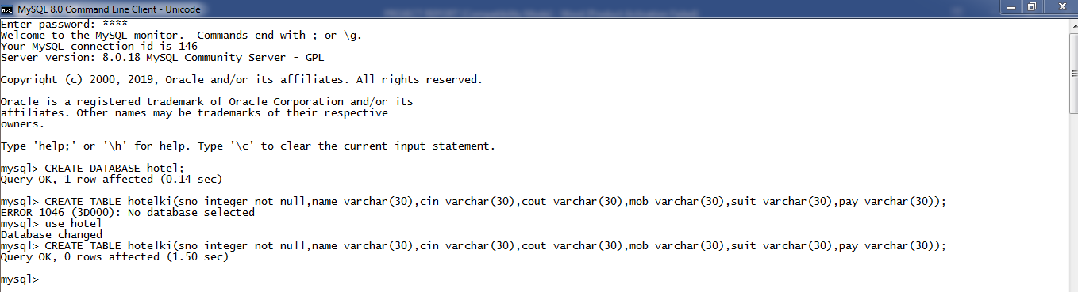

SOURCE CODE FOR CONNECTING MySQL WITH
PYTHON APPLICATION AND PROJECT

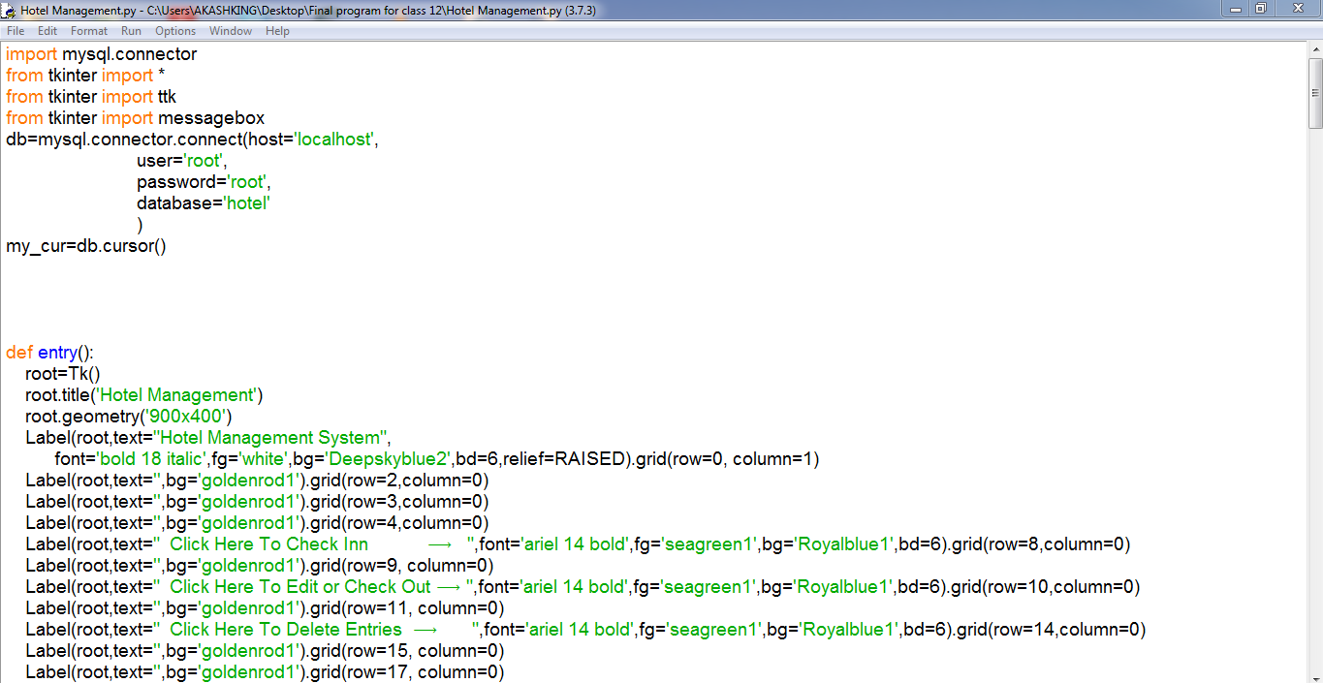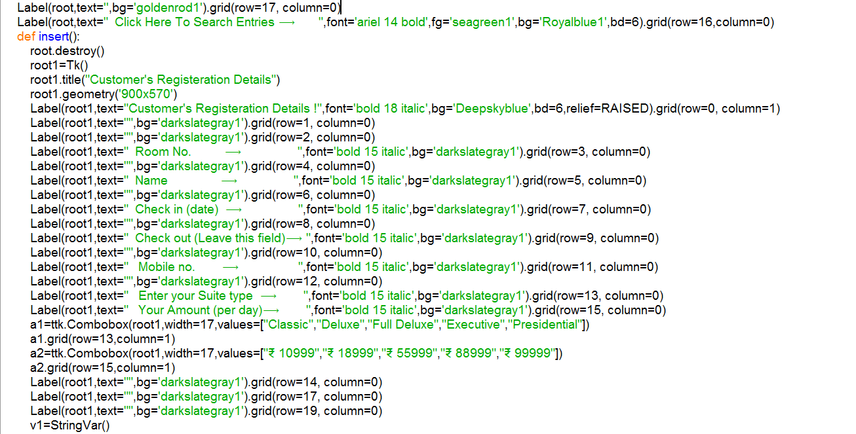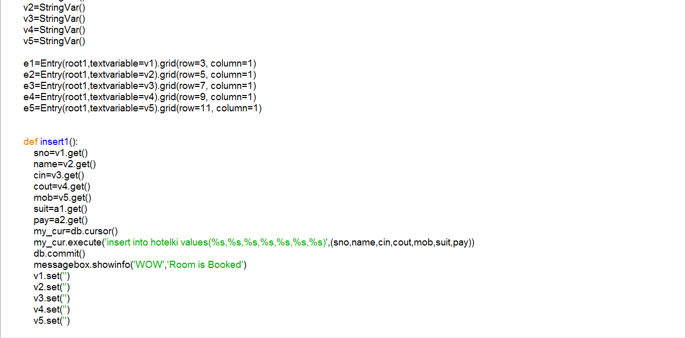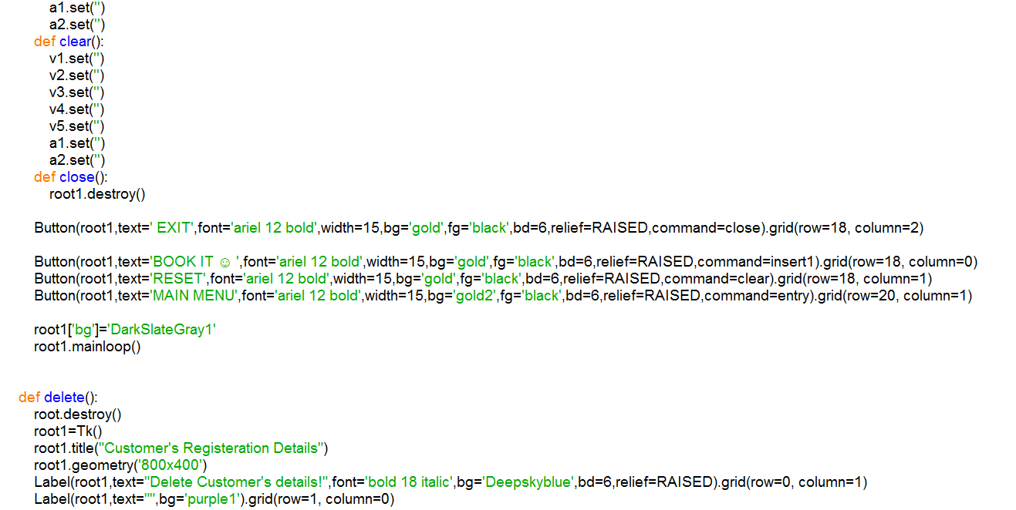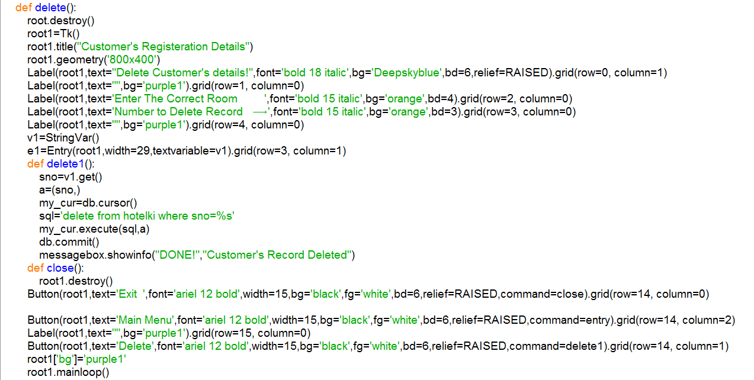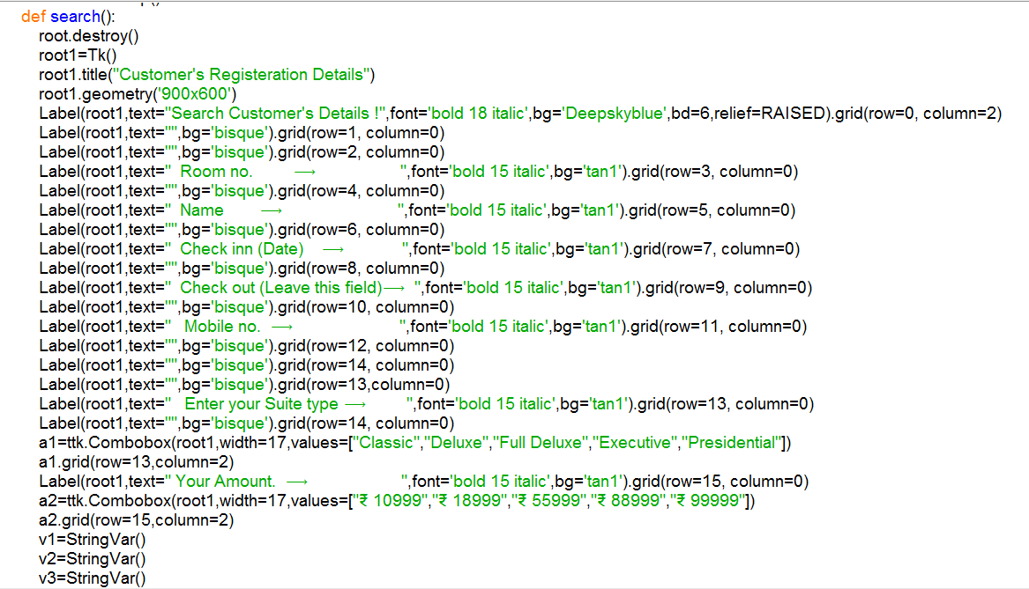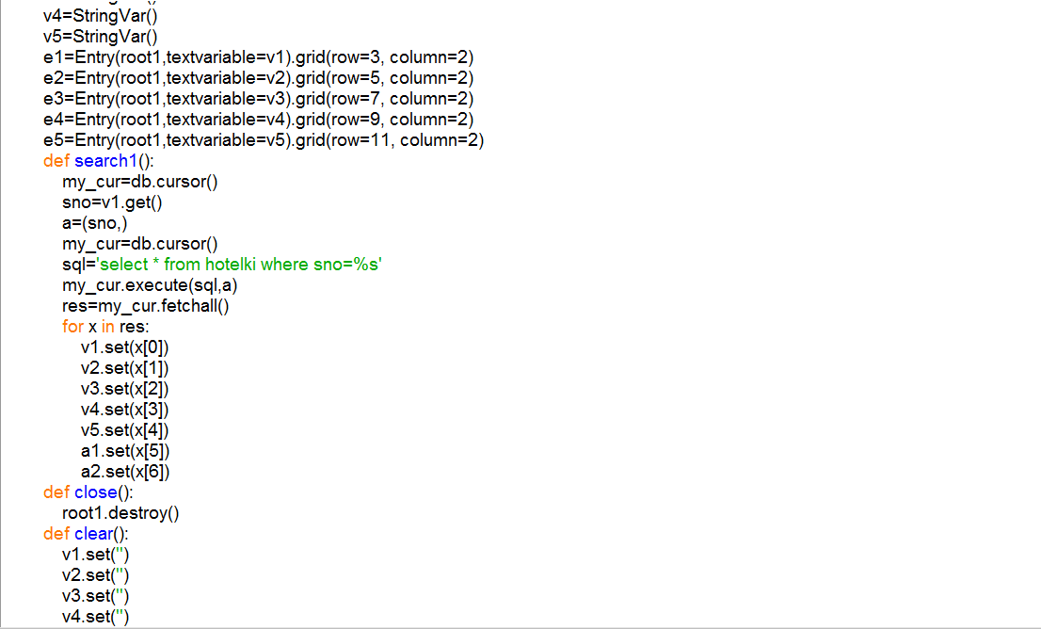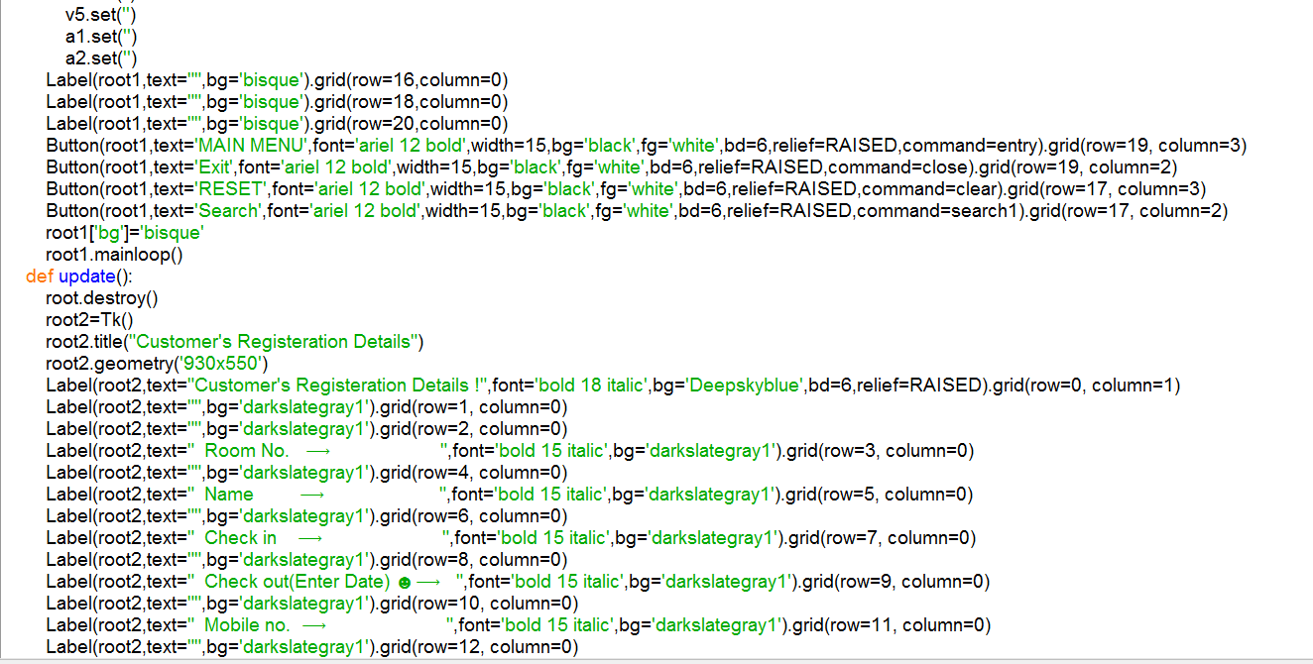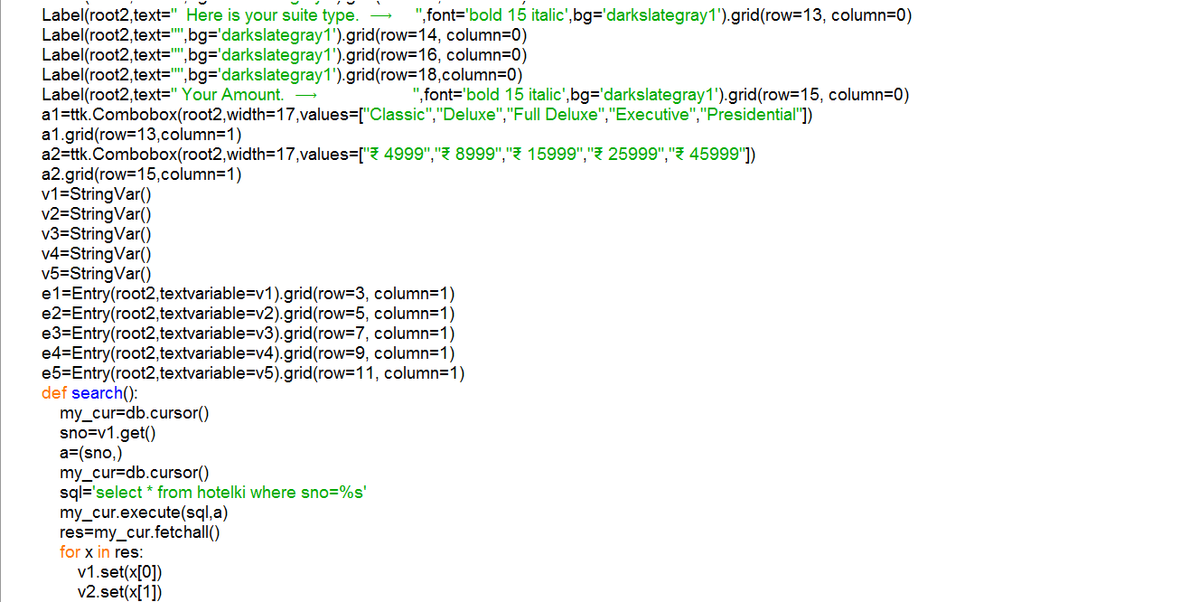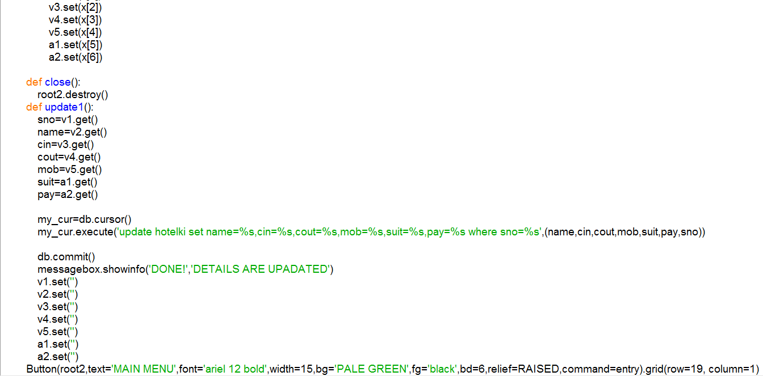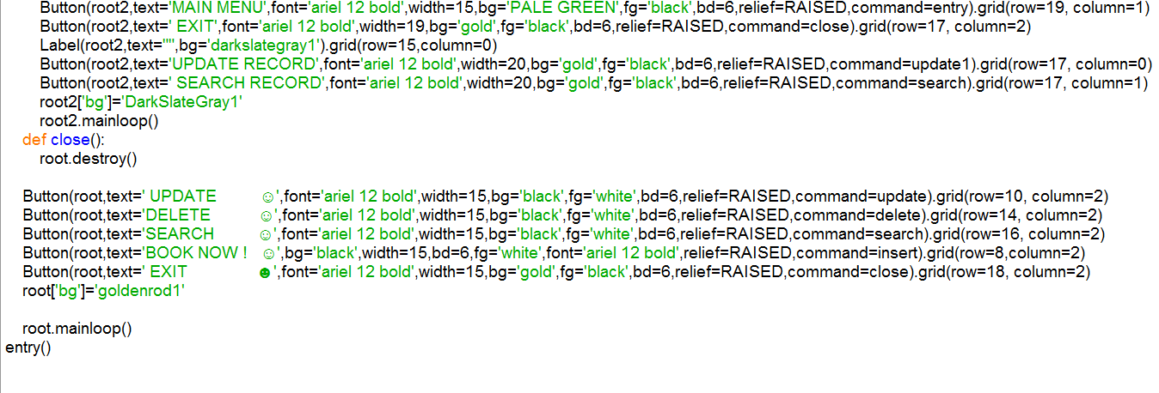

SAMPLE RUN
Main Menu:-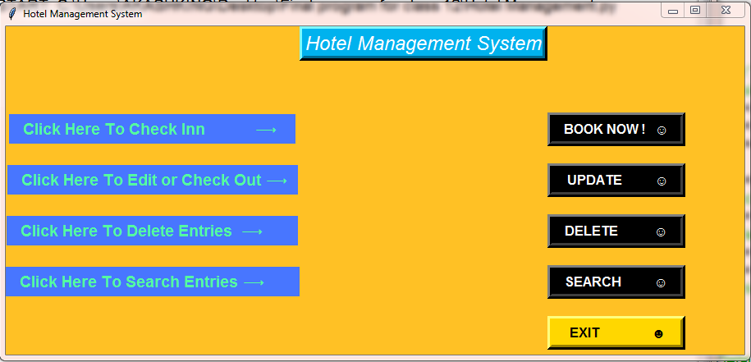
On clicking Book now Button :-
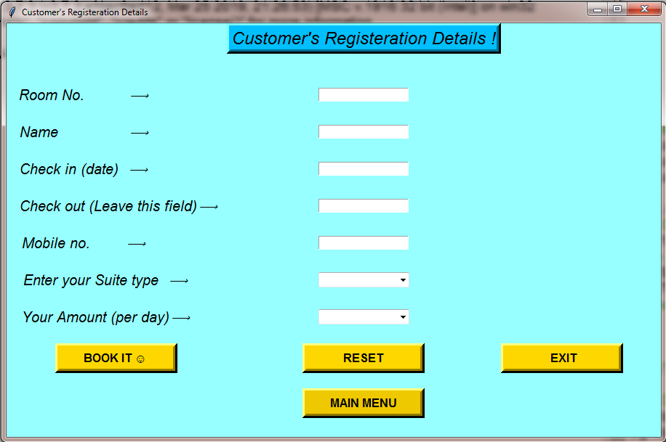
On clicking Update button :-
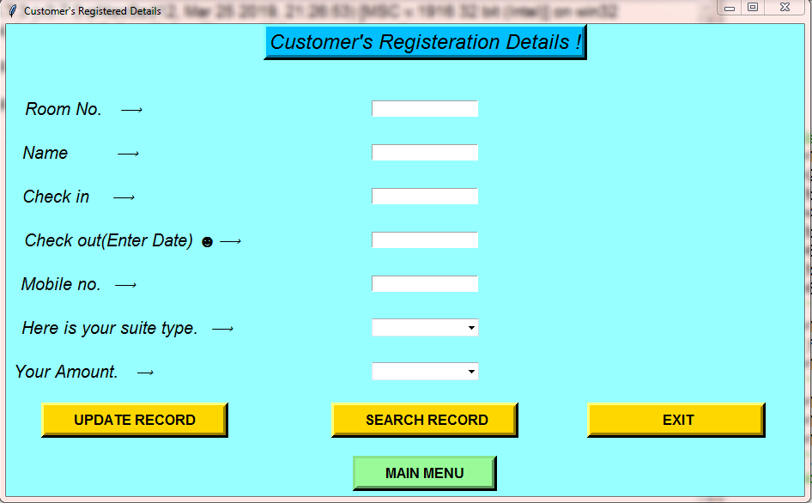

On clicking Delete button :-
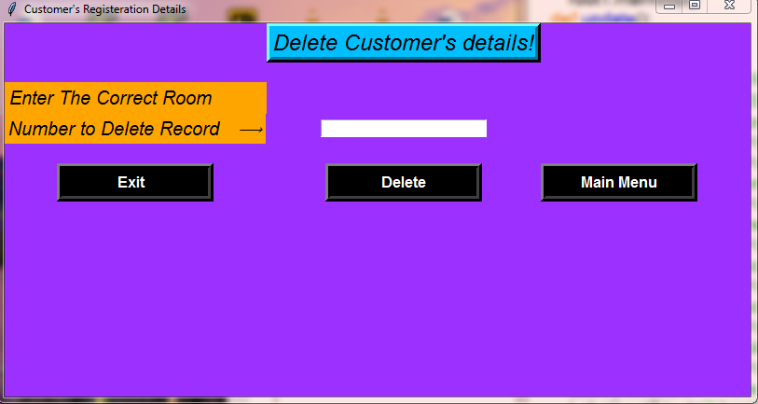
On clicking Search Button :-
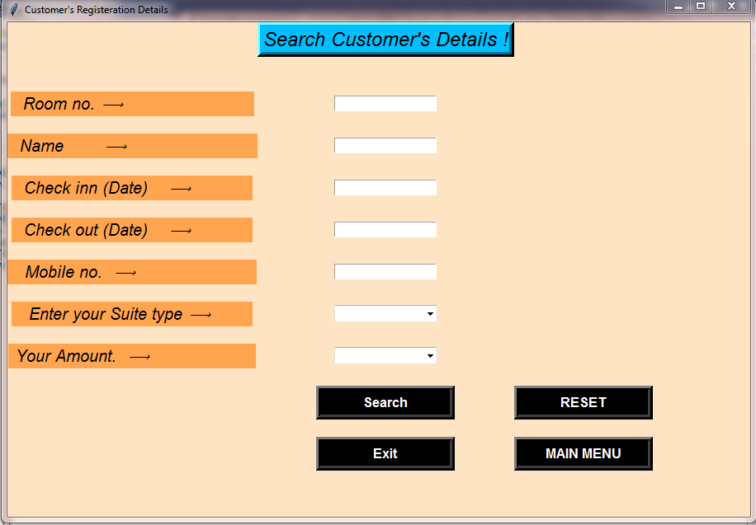

SUGGESTIONS FOR IMPROVEMENT

- Biometric information such as fingerprint, retinal scan etc. should be included in the system to ensure good security of the system thereby avoiding impersonation and unauthorized access to stored data thereby preventing loss of vital information.
- Implementation hotel management control system in delivery of service to customers.
- Connecting the program online and reserving rooms online.
- Provision should be made for customers to interact with authorized users of the hotel for reservation using their mobile phones.

BIBLIOGRAPHY

 www.google.com
 www.tutorialspoint.com
 www.geeksforgeeks.org

 www.stackoverflow.com

 www.pythonforstudents.blogspot.com

 REFERENCES TAKEN FROM SUMITA ARORA.

